**Experiment No. 6**

**Aim:** Backing up and restoring files: Selecting backup strategy, Magnetic tape, Writable CD`s, Backing up hard drive, Backing up files with dump, Automating back up, Restoring backed up files.

1. **Create folder on desktop and create 2 folders in it:**

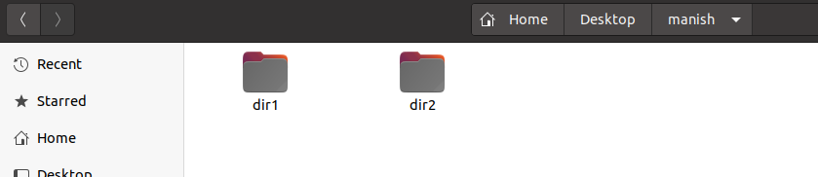

1. **Create an uncompressed tar archive of files:**

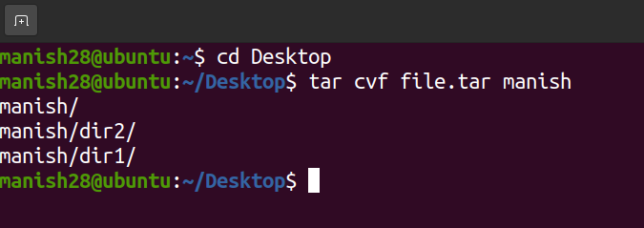

1. **Viewing the archive using option -tfv:**

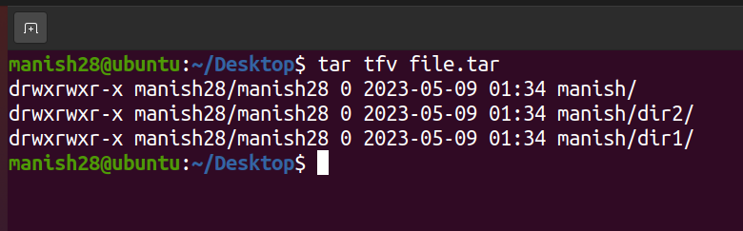

1. **Extracting files from archive using option -xvf:**

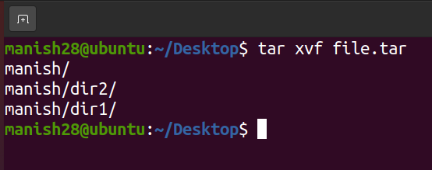

1. **Option -czfv:**

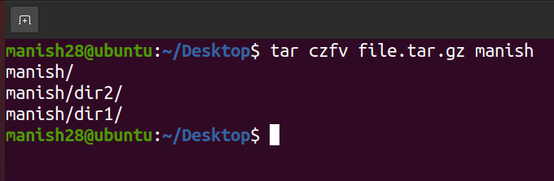

1. **Option rm (to remove files from archive) and list those files:**

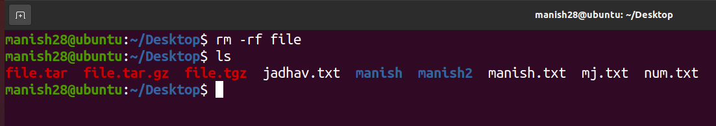

1. **To extract the files in an archived form and listing them:**

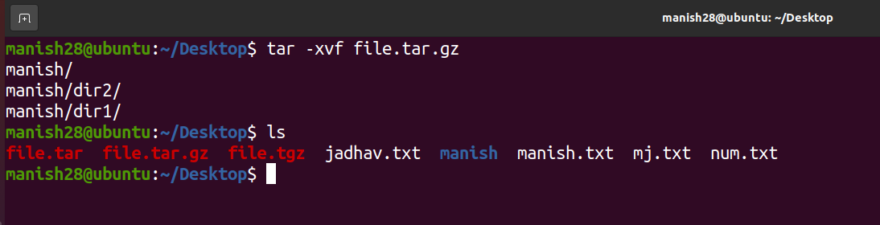

1. **Changing directory to working folder and creating a new folder:**

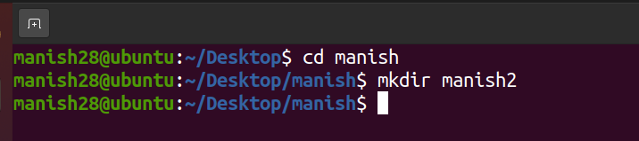

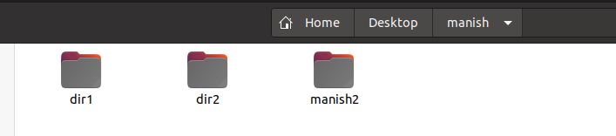

|  |  |  |  |
| --- | --- | --- | --- |
| **Practical Performance**  **(4)** | **Writeup & Oral**  **(4)** | **Attendance**  **(2)** | **Total**  **(10)** |
|  |  |  |  |